Frequency Distributions

- Fill out the rest of this simple distribution table by calculating the relative frequency, cumulative frequency, and cumulative percent. Round final answers to the 2nd decimal place.

X | f | rf | cf | c%
10 | 5 | .08 | 60 | 100%
9 | 0 | .00 | 55 | 92%
8 | 10 | .17 | 55 | 92%
7 | 20 | .33 | 45 | 75%
6 | 25 | .42 | 25 | 42%
N = 60

- Using the data set given below. Create a simple distribution table by calculating the relative frequency, cumulative frequency, and cumulative percent. Round final answers to the 2nd decimal place.

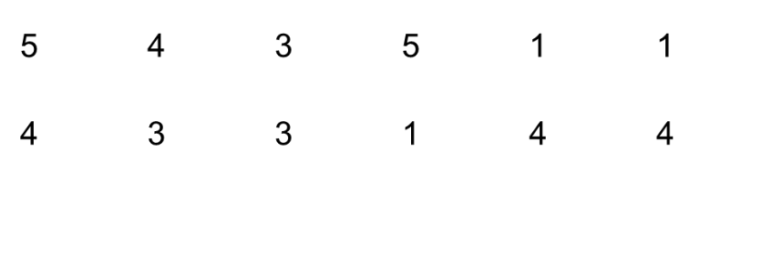
X | f | rf | cf | c%
5 | 2 | .17 | 12 | 100%
4 | 4 | .33 | 10 | 83%
3 | 3 | .25 | 6 | 50%
2 | 0 | .00 | 3 | 25%
1 | 3 | .25 | 3 | 25%

- A police radar unit measured the speed of 25 cars on Elm Street. The resulting speeds were: 29, 23, 30, 30, 27, 24, 30, 25, 23, 28, 25, 24, 28, 30, 23, 30, 27, 25, 29, 24, 23, 26, 30, 28, and 25.
  - Create a simple distribution table by calculating the relative frequency, cumulative frequency, and cumulative percent. Round final answers to the 2nd decimal place.
  - Draw a histogram to represent these data.

X | f | rf | cf | c%
30 | 6 | .24 | 25 | 100%
29 | 2 | .08 | 19 | 76%
28 | 3 | .12 | 17 | 68%
27 | 2 | .08 | 14 | 56%
26 | 1 | .04 | 12 | 48%
25 | 4 | .16 | 11 | 44%
24 | 3 | .12 | 7 | 28%
23 | 4 | .16 | 4 | 16%

Speed
23 24 25 26 27 28 29 30
Frequency

