Central Tendency

- A die was rolled 30 times with the following results:
6, 5, 4, 4, 5, 6, 1, 2, 1, 6, 4, 3, 3, 3, 4, 2, 2, 5, 6, 4, 1, 2, 4, 3, 5, 5, 3, 3, 4, 2
- Prepare a frequency distribution for this data.
- Calculate the mean, median, and mode of the numbers rolled.

X | f | rf | cf | c%
6 | 4 | .13 | 30 | 100%
5 | 5 | .17 | 26 | .87%
4 | 7 | .23 | 21 | 70%
3 | 6 | .20 | 14 | 47%
2 | 5 | .17 | 8 | 27%
1 | 3 | .10 | 3 | 10%
N = 30; Mean = 3.6; Median = 4; Mode = 4

- Gary has taken an aptitude test 8 times and his scores are 96, 98, 98, 105, 36, 87, 95, and 93.
  - Calculate the mean, median, and mode for these data.
  - If you could only report one measure of central tendency, which is most appropriate for the given situation?

36, 87, 93, 95, 96, 98, 98, 105
N = 8; Σx = 708; Mean = 88.5; Median = 95.5; Mode = 98
Median, because the distribution is skewed.

- The data shown are the grades received by fifteen students of Mrs. William's class.
A, B, B, B, C, A, B, B, A, B, C, B, B, B, A. Which measure of central tendency is the best for the given situation?
Mode

- Match the Distribution Curves – Options: Leptokurtic, Bell Curve, Mesokurtic, Platykurtic
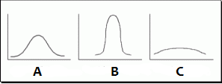

A. Mesokurtic or Bell curve B. Leptokurtic C. Platykurtic

- Identify the distribution as negative, positive, or normal and identify which measure of central tendency is best to use for each.

  - 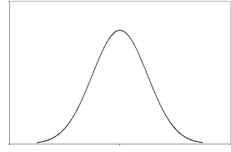
  - 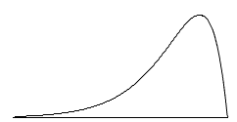
  - 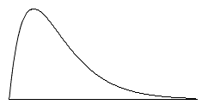

A. Normal / Mean B. Negative / Median C. Positive / Median

